**PRACTICAL NO : 03**

**Title : Creating an Application in SalesForce.com using Apex programming Language**

**STEPS TO CREATE AN APPLICATION :**

**Step No 1**: Create new org:

https://developer.salesforce.com/signup

**Step No 2**: After signup, logging using following URL https://login.salesforce.com/

**Step No 3**: Login Page (Enter your credential to login)

1. Open Developer Console

2. File ---> New ---> Select Apex Class

3. Type below mentioned code

public class FirstClass1

{

public static void firstMethod()

{

System.debug('WELCOME TO PGMCOE');

}

}

**Note : you can write any code as application**

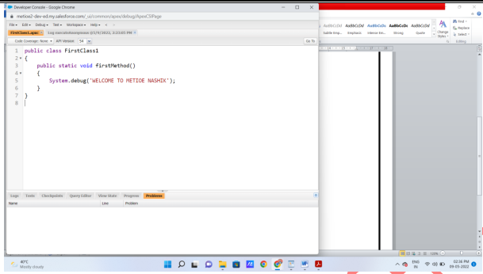

4. Click on Debug ---> Open Execute Acronymous Window

5. Type below code(Apex Code)

FirstClass1.firstMethod();

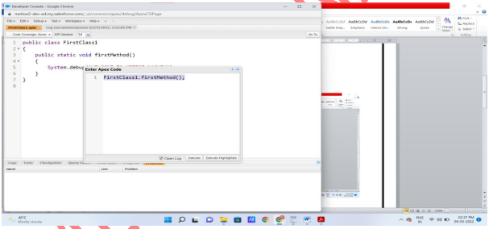

6. Click on Open log then Execute code

7. Click on Debug only (You will get output)

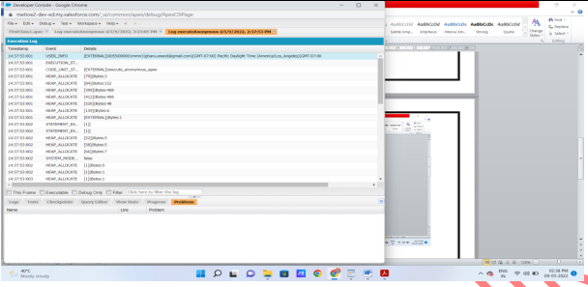

**Output :**

